kHR Team

Zachary DiPasquale, Thomas Faticone, Ephraim Gbadebo, Jarrod Cummings

SWEN-343 Enterprise

**Demo R1/ Demo Script / Demonstration of Functionality**

URL: <http://kennuware-1772705765.us-east-1.elb.amazonaws.com/>

# Employee

**Description**

The employee component holds the personal information needed by KennUware Corp. for each employee. Details include name, address, phone number, salary information, region, department, role, and position. The Employee system also includes an API endpoint so other silos can access information about the employees.

**Screenshots of the employee web pages**

## List

Within the employees section, HR should be able to see a list of employees. Each row pertains to a single employee and enables the HR rep to edit, delete, and get further details on a single employee.

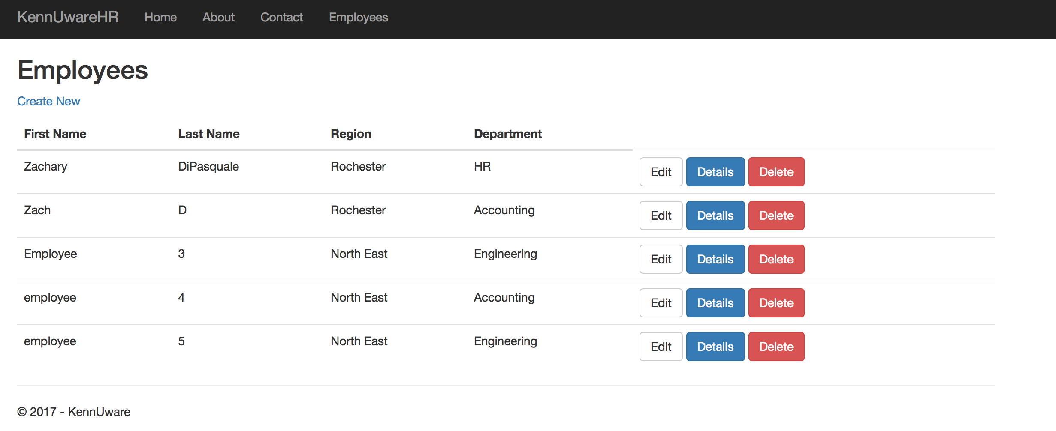

## Create

The create page will enables HR employees to create new employee profiles

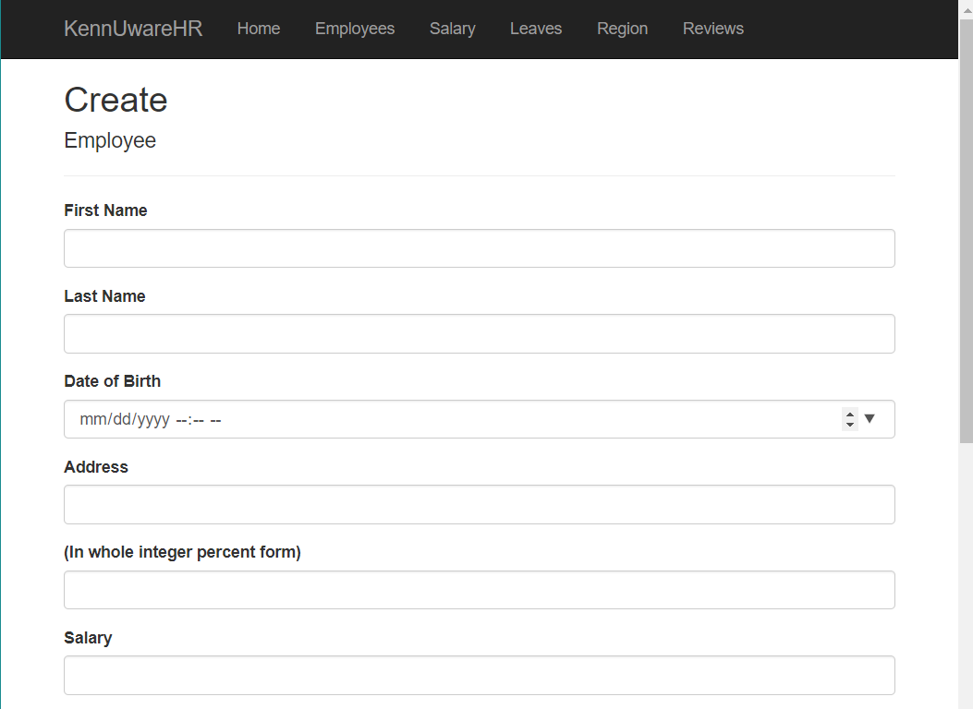

## Edit

The edit page allows HR employees to edit a specific employee’s information.

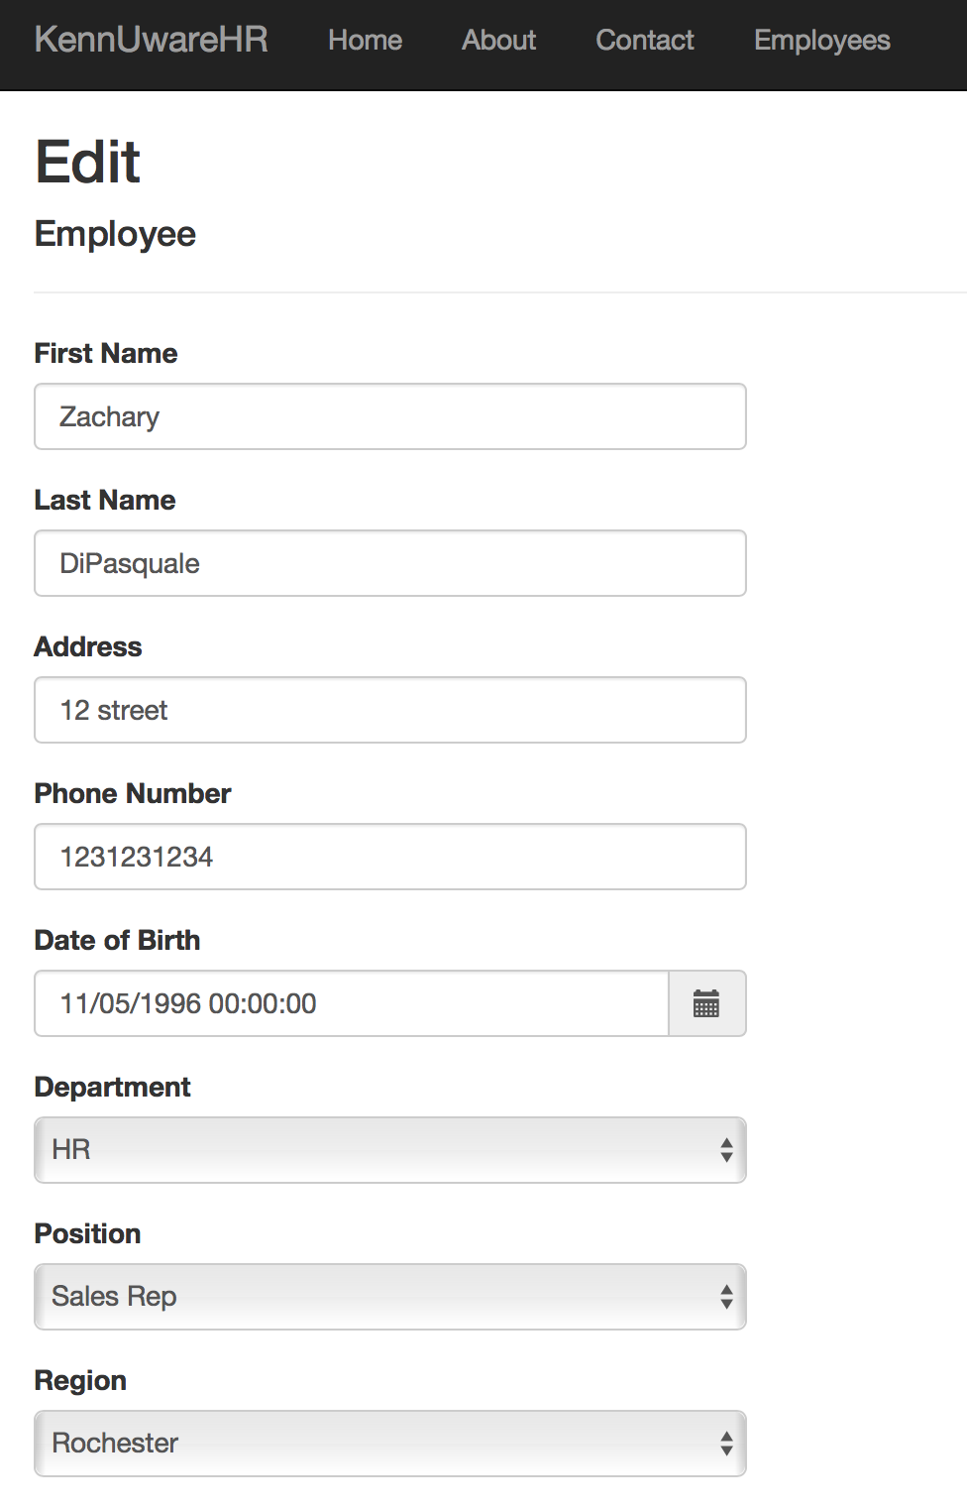

## Endpoint

*GET /api/employee*

Returns a list of employees and their information based on filters provided in the url params

URL parameters:

* id: the id of an employee
* department: the depart of employees to filter by
* position: the position of the employee to filter by
* region: the region of the employee to filter by
* pageNum: the page of the results to return
* limit: the number of results to return, Default 25

Example Requests

/api/employee?id=3

|  |
| --- |
| {  "id": 3,  "firstName": "Zach",  "lastName": "D",  "dateOfBirth": "1996-11-05T00:00:00",  "regionName": "Rochester",  "roleName": "Admin",  "departmentName": "Accounting",  "positionName": "Board Member" } |

*/api/employee?pageNum=1&limit=4*

|  |
| --- |
| {  "data": [  {  "id": 1,  "firstName": "Zachary",  "lastName": "DiPasquale",  "dateOfBirth": "1996-11-05T00:00:00",  "regionName": "Rochester",  "roleName": "Admin",  "departmentName": "HR",  "positionName": "CEO"  },  {  "id": 3,  "firstName": "Zach",  "lastName": "D",  "dateOfBirth": "1996-11-05T00:00:00",  "regionName": "Rochester",  "roleName": "Admin",  "departmentName": "Accounting",  "positionName": "Board Member"  },  {  "id": 4,  "firstName": "Employee",  "lastName": "3",  "dateOfBirth": "2018-11-11T00:00:00",  "regionName": "North East",  "roleName": "HR",  "departmentName": "Engineering",  "positionName": "Board Member"  },  {  "id": 5,  "firstName": "employee",  "lastName": "4",  "dateOfBirth": "1996-12-12T00:00:00",  "regionName": "North East",  "roleName": "HR",  "departmentName": "Accounting",  "positionName": "Board Member"  }  ],  "page": {  "nextPage": "?pageNum=2&limit=4"  } } |

# Salary

## List

This page enables HR(at the present time) to view all paychecks within the system). This can be accessed by clicking “Salary” in the navbar.

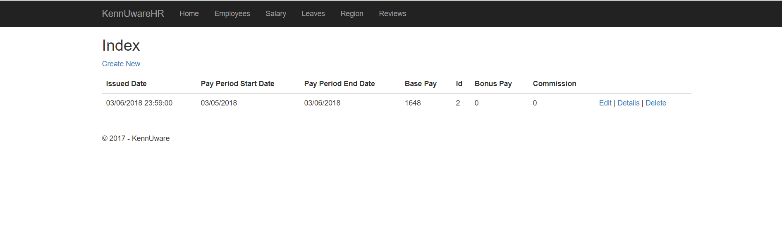

## Create

This page will enable an HR representative to create paychecks for ALL employees in a given time frame. This can be accessed by clicking “Create New” in the Salary Index.

**Entered Data**

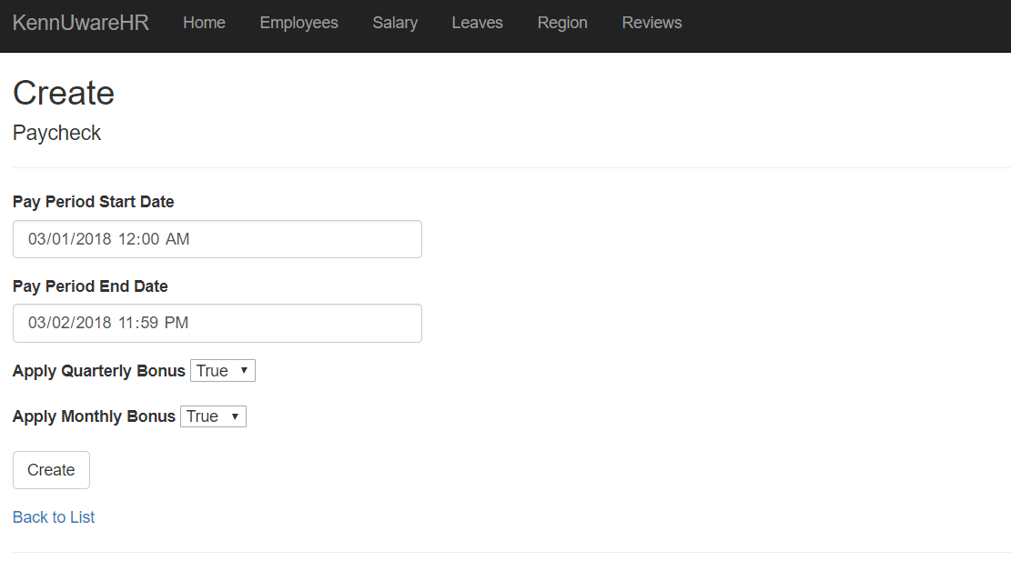

**Result**

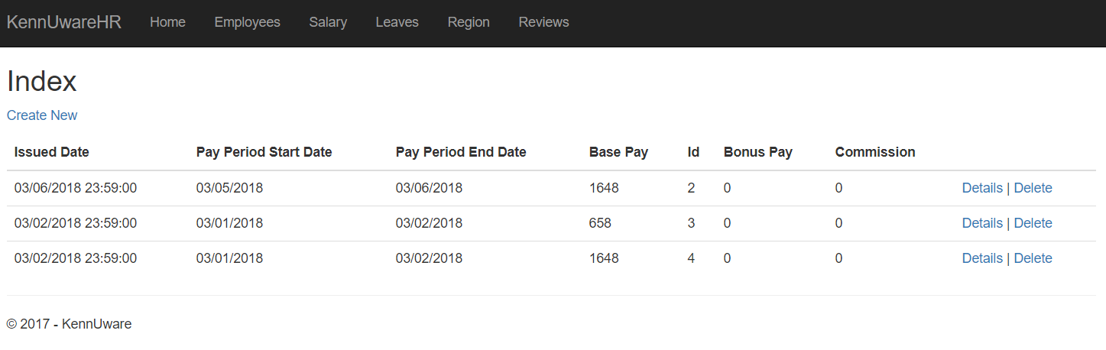

## Detail

This will enable HR representatives to view the specifics of a given paycheck. This can be accessed by clicking “Details” of a specific paycheck.

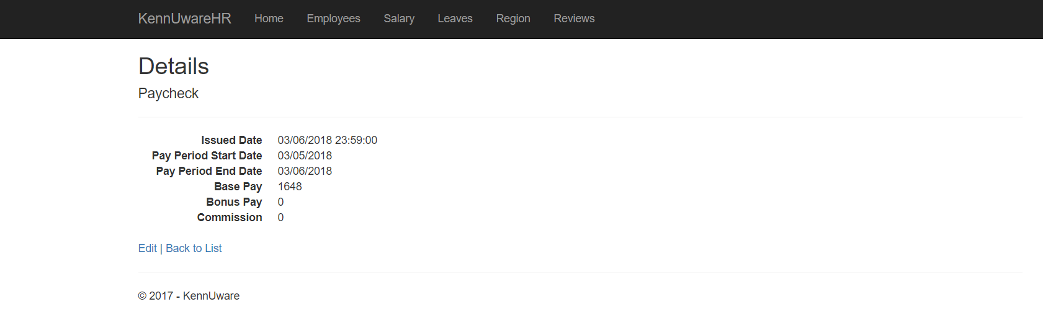

## Endpoint

*POST /api/salary*

*This endpoint is currently being taken care of by the Create Salary Page. Here are the Request/Return object details.*

**Request Object**

|  |  |  |  |
| --- | --- | --- | --- |
| Name | Type | Description | Example |
| startDate | string | Indicates the start for the range of dates paychecks should be calculated for. | “2008-05-01 12:00:00Z” |
| endDate | string | Indicates the end for the range of dates paychecks should be calculated for. This should be after the start date. | “2008-05-02 12:00:00Z” |
| quarterlyBonus | string | Signifies a boolean indicating whether the quarterly bonus should be applied to a paycheck. | “true” |
| monthlyBonus | string | Signifies a boolean indicating whether the monthly bonus should be applied to a paycheck. | “false” |

**Return Object**

|  |  |  |  |
| --- | --- | --- | --- |
| Name | Type | Description | Example |
| startDate | string | Indicates the start for the range of dates paychecks have been calculated for. | “2008-05-01 12:00:00Z” |
| endDate | string | Indicates the end for the range of dates paychecks have been calculated for. | “2008-05-02 12:00:00Z” |
| lumpSum | string | Signified the total amount of money that has been expended by the payout of all paychecks for all employees within the range. | “3400002.24” |

# Leave

**Description**

The Leave component keeps track of employee requests for leave of absence. Each Leave object is associated with a particular employee and includes a start date, end date, and approval status. All Leaves are initially created with an approval status of false and must be manually approved.

## Create

In the create form an employee can set a start and end date for their requested leave. While in this example the employee associated with the leave is selectable, this will not be the case once we have properly implemented permissions.

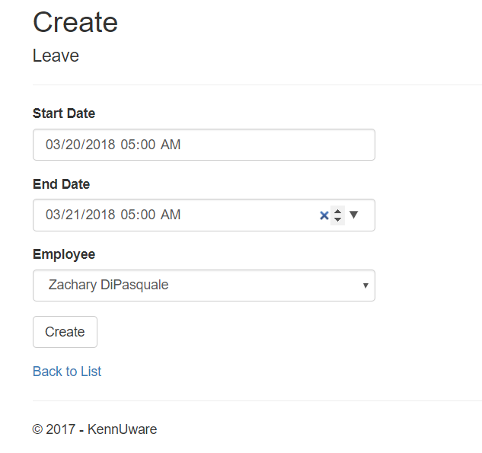

The created leaves can be seen in the index below, as can be seen on the right, their approved status is set to false. This particular index will be removed eventually, but for now will be used for demonstration purposes.

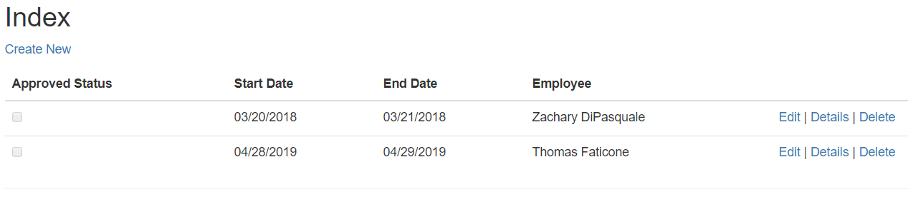

## Approval

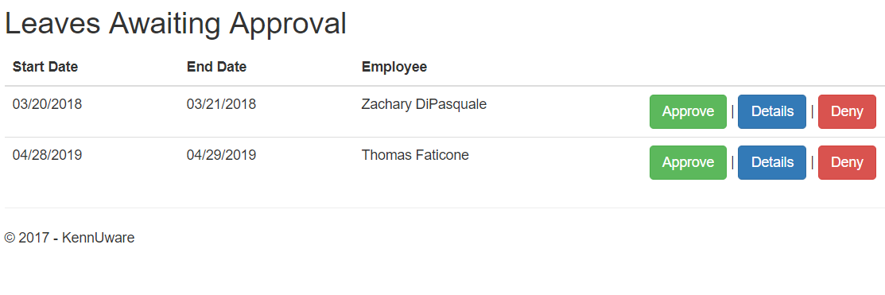

When leaves are created they are unapproved and will show up here in the awaiting approval page. From here the details button can be used to view the information on a particular leave. By clicking approve, you will be brought to the following form.

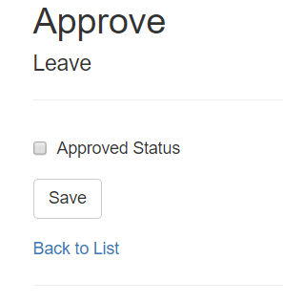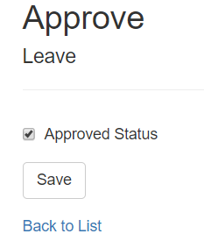

Checking the box and clicking save will set the Leave’s status to approved. As such, it will no longer show up in the awaiting approval page.

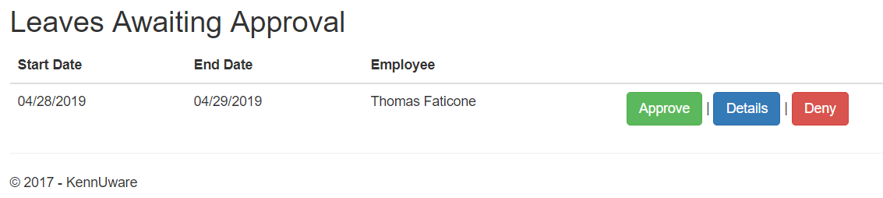

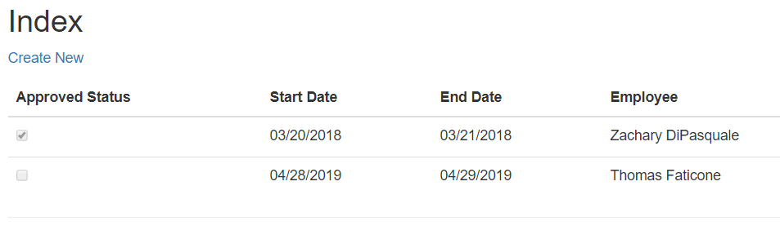

## Denial

It is also possible for a leave request to be denied. In this case denying a leave request is the same as deleting it and it will be removed from the database.

 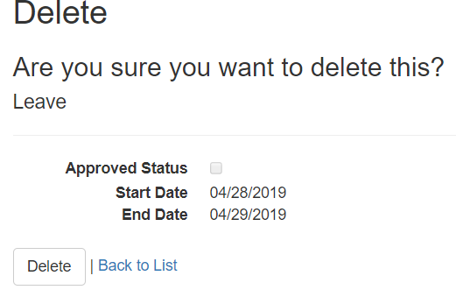

Should the deny request be made, the leave will no longer appear in the awaiting approval queue, nor in the index, as it has been deleted.

